TERM 1.

SUMMATIVE ASSESSMENT TASKS

Summative assessment for the unit “Hobbies and Leisure”

Learning objectives | 7.L4 Understand with little support some of the implied meaning in extended talk on a limited range of general and curricular topics  7.UE1 Use some abstract nouns and complex noun phrases on a  limited range of familiar general and curricular topics
Assessment criteria | - Apply some abstract nouns and complex noun phrases in the context  - Identify the main idea in extended talks with little support
Level of thinking skills | Knowledge and comprehension Application
Duration | 20 minutes

Reading

Task1. People are talking about hobbies and pastimes. Listen and number the pictures.
https://english-practice.net/listening-exercises-a2-hobbies-and-pastimes/
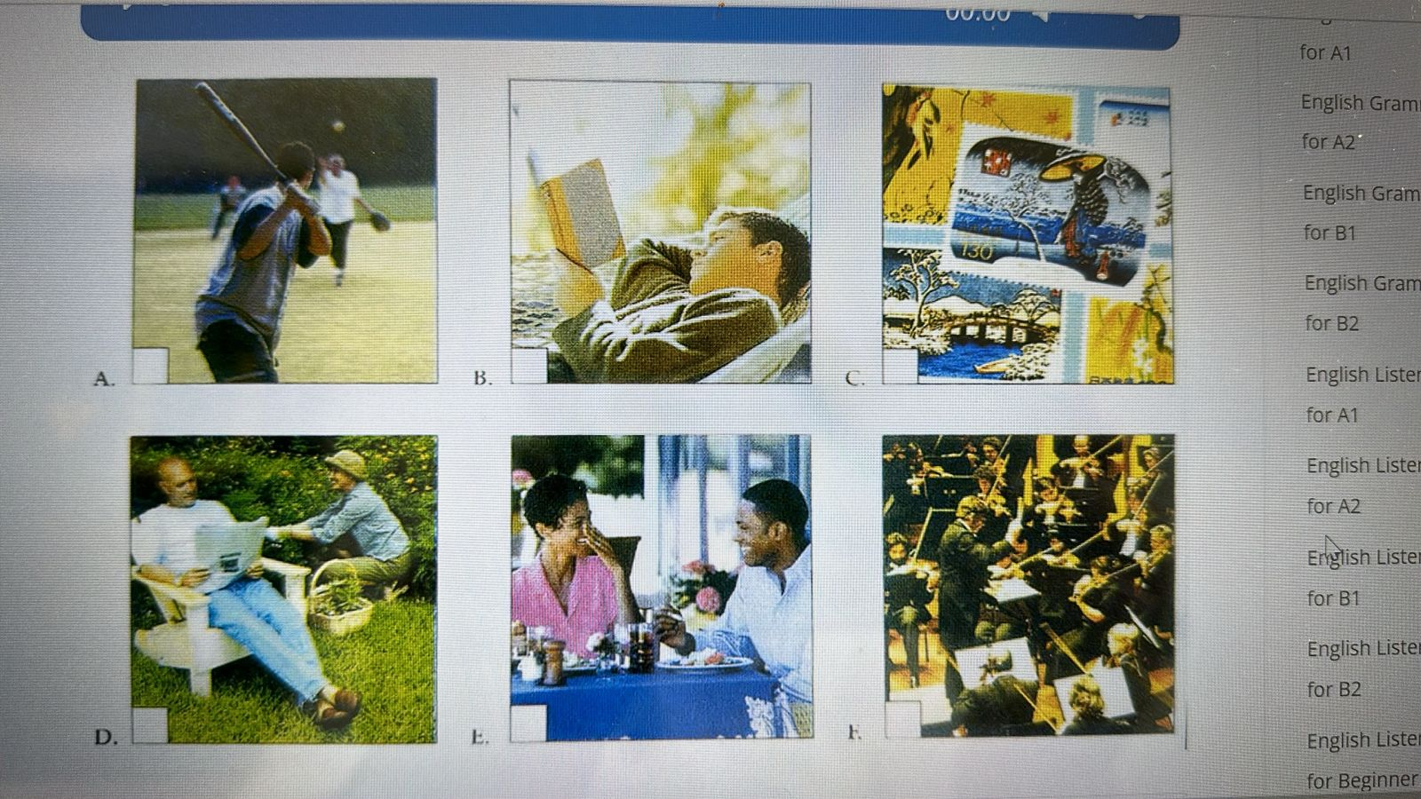
f
e
d
c
b
a
Writing
Task 2. Read nouns in the box and write only abstract nouns. Complete the table with 4 abstract nouns. There are more than 4 of them in this task. Number 1 is done for you.
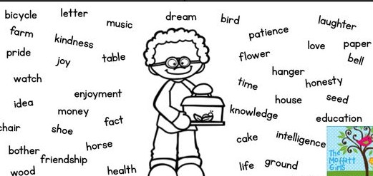

1.music | 4.
2. | 5.
3.

Assessment criteria | Task | Descriptor | Mark
Assessment criteria | Task | A learner | Mark
Identify the main idea in extended talks. | 1 | A 5 | 1
Identify the main idea in extended talks. | 1 | B 2 | 1
Identify the main idea in extended talks. | 1 | C 3 | 1
Identify the main idea in extended talks. | 1 | D 4 | 1
Identify the main idea in extended talks. | 1 | E 1 | 1
Identify the main idea in extended talks. | 1 | F 6 | 1
Apply some abstract nouns and complex noun phrases in the context | 2 | 2 love | 1
 | 2 | 3 dream | 1
 | 2 | 4 life | 1
 | 2 | 5 pride | 1
Total marks |  |  | 10

Answer & Transcript
1. I love to eat out. I eat at restaurants most of the time. It’s expensive, but I don’t care.
2. I read almost everything I can: books, magazines, newspapers. I go to the public library about twice a week.
3. I never used to like stamp collecting, but now I think it’s great. I’ve got two huge stamp albums. Hey, why don’t you come and see my collection some time?
4. My wife says I should take up gardening. We have a big garden, and she loves working in it, but the truth is, it bores me.
5. Well, everyone in my family loves sports – everyone, that is, except me. My family’s out playing baseball and stuff all the time. But I think most sports are pretty boring. I don’t like chasing balls around a field. And I couldn’t hit a ball if I had to.
6. My friends think I’m really boring because I’m always listening to music. I go to concerts all the time. I love Mozart and all that classical stuff.

